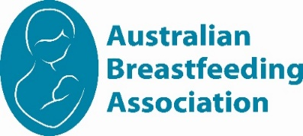

Illawarra 2025

Calendar of events

|  |  |  |  |  |  |  |
| --- | --- | --- | --- | --- | --- | --- |
| Mon 24 March 0930am | Walk and Talk | | | Keiraville | | |
| Tue 8 April 1030am | Walk and Talk | | | Kanahooka | | |
| Mon 19 May 10am | Walk and Talk | | | Keiraville | | |
| Wed 18 June 1030am | Walk and Talk | | | Kanahooka | | |
| Mon 28 July 10am | Walk and Talk | | | Keiraville | | |
|  | **www.breastfeeding.asn.au** | |  | | |
|  | |  | | |

**Please check for any changes of date/venue on Facebook**

**ABA Illawarra**

<https://www.facebook.com/BreastfeedingIllawarra>

**Meet Up’s**

**3rd Wednesday of the Month at Kanahooka Reserve**

Lakeside Drive, Kanahooka, NSW 2530

**3-4th Monday of the Month at Wollongong Botanic Gardens**

**Wollongong Botanic Gardens**

40 Murphy’s Ave, Keiraville NSW 2500

Whether you are awaiting the arrival of your first baby, breastfeeding or bottle feeding – all mothers, fathers, their children, support people and friends are most welcome to attend our meetings and social gatherings. Our meetings are very informal and while a nominated topic is set for most meetings, there is always an opportunity to discuss other topics of interest as a group or individually with a counsellor.

Our groups usually meet at **Wollongong Botanic Gardens** and **Kanahooka Reserve Lakeside Drive**

**See the ABA website calendar for information about virtual meetings offered by groups around Australia**

We look forward to meeting you. Naomi and Candice ABA Illawarra Team

North Western Sydney Region 2020-21

Calendar of events

|  |  |
| --- | --- |
|  | |
| Illawarra Group Leader |
| Naomi  0423693484  [illawarraaba@breastfeeding.asn.au](mailto:illawarraaba@breastfeeding.asn.au) |
|  |
| **Mother Safe Medication Info Line** 9382 6539  **Poisons Information**  13 11 26 |
| Breastfeeding Helpline  **1800 686 268**  **The Breastfeeding Helpline is supported by funding from the Australian Government**  [www.breastfeeding.asn.au](http://www.breastfeeding.asn.au) |

