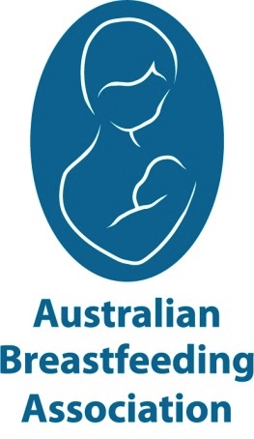
Breastfeeding Education Classes

PLANNING TO BREASTFEED?
2024
10  February | 13  April | 15  June | 17  August | 19  October | 30 November
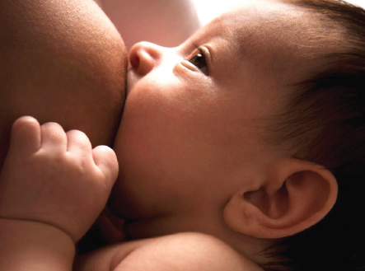

For more information please contact:

Mary 0452 485 310
aba.darwin@gmail.com
Australian Breastfeeding Association Darwin/Palmerston/Rural Group

www.breastfeeding.asn.au

www.eventbrite.com.au
1
and search ‘ABA Darwin’

Book online with

All classes are held on Saturday from 1pm - 5pm

Come to a relaxed, information-packed Breastfeeding Education Class for expectant parents and support people. Classes are presented by trained volunteer Breastfeeding Counsellors and cover a range of topics including:

- How breastfeeding works
- Breastfeeding in the early days
- Parenting in the early days
- Information for fathers and support people
- Where to go if you need help

Although breastfeeding is natural, it is a learned skill.
Our classes aim to provide parents with the knowledge and confidence to successfully breastfeed.

Cost: $70 per couple including class, afternoon tea and ABA Virtual Village access for 12 months – total value over $260.

ABA Virtual Village access includes: Free breastfeeding eBook and magazine subscription, unlimited access to the Newborn Virtual Village, breastfeeding hints and tips direct to mobile, unlimited access to online Connect and Share sessions, access to ABA local events, discounted breast pump hire, mum2mum app life and access to meet-ups in the app.
Memberships | Australian Breastfeeding Association

-

Too busy to attend face to face?
Check out the online introductory class for $90
Memberships | Australian Breastfeeding Association

